**Quiz 2**

Code for this quiz is given in the github repository for the course. The relevant file is **02_24-100pwm.c** Direct link: <https://github.com/ntmoore/physics333_spring20/blob/master/02_24-100pwm.c>

The example file contains a function, *pwm_100()*, that implements a PWM algorithm with 1 out of 100 fidelity (rather than 1 out of 1000 fidelity in the old *ntm_pwm()* function – see line 50 specifically in the source code).

The code also has some basic error checking that’s enabled if line 3, “#define WARNINGS” is active (and not commented out). This line basically turns on the lines encapsulated by the “#ifdef WARNINGS” and “#endif” blocks (lines 29 and 43).

1. With **#define Warnings** active (uncommented) the code as written sends the following error message to the serial monitor (check it yourself!)

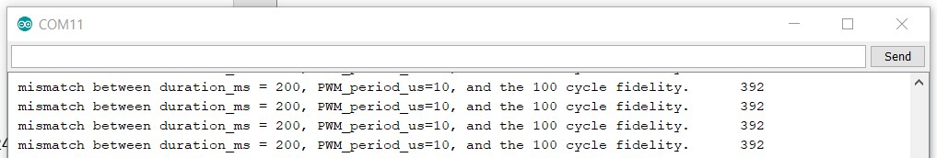

This is not how the error message should work, because (line 37),

(200*1000)%100*10 = 0, not 392.

Question: what’s going on? Hint, *long* might be useful.

**The Arduino Uno uses 16 bit integers, which gives them a range from -32,768 to 32,767**

**200*1,000 = 200,000 which is much bigger than 32,767. The number is wrapping around to the negative end, and overflowing over and over to what eventually looks like 392.**

**Using a long instead extends this range to roughly -2 billion to positive 2 billion, which is plenty for this calculation.**

1. Please fix the conditional in line 37 so that the error is:
   1. active for a function call of pwm_100(200, 99, 7, 10);
   2. not active for a function call of pwm_100(300, 99, 6, 10);
2. Turn off the warnings by commenting out line 3, *#define WARNINGS*

Then, imagine that the code consists of: 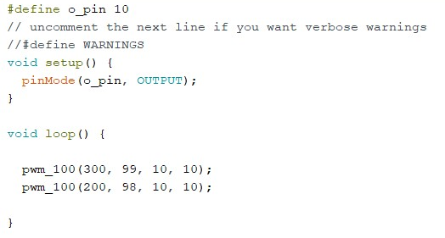

This file is given in the gitub repo if you need it, <https://github.com/ntmoore/physics333_spring20/blob/master/02_24_quiz_p3-4.c>

What will the signal look like if you average it out by feeding the signal to a big-enough capacitor and resistor, ie $RC≫1ms$, in series to ground?

1. Assuming 5.0v is the Arduino’s high logic level, with what tolerance can your PWM specify analog output voltage values? Or, in other words, what average output voltage difference corresponds to the step between power=99 and power=98?